# DESSERT COCKTAILS

**Chocolate Martini**

Godiva Dark Chocolate Liqueur, Kahlua,

Vanilla Vodka & Cream|12

**Kahlua Supreme**

Kahlua, Grind Espresso Coffee Liqueur,

Vanilla Vodka, Crème de Menthe & Cream|10

**Grasshopper**

Godiva Dark Chocolate liqueur, Vanilla Vodka,

Crème de Menthe & Homemade Blended Whip Cream|10

**Doncaster’s Butterscotch**

Butterscotch Liqueur, Baileys & Cream & Homemade Blended Whip Cream |10

# BOURBON & WHISKIES

| **American Whiskey**

***Bourbon***

Angel’s Envy

Angel’s Envy Cask

Basil Hayden

Basil Hayden Subtle Smoke

Bulleit

Buffalo Trace Single Barrel

Elijah Craig 1792

Four Roses Single Barrel

Four Roses Small Batch

Jim Beam Masterpiece

J. Rieger

Knob Creek

Knob Creek 12yr

Knob Creed 15yr

Maker’s Mark

Maker’s Mark 101

Maker’s Mark 46

Maker’s Mark 46 Cask

Nelson Green Brier

Rabbit Hole Cavehill

Rabbit Hole Heigold

Russell’s Reserve

Stellum

Mahogany Select Barrel

*Stranahans*

*Woodford Reserve*

***Rye***

Highwest Double Rye

Highwest Midwinter Dram

Rabbit Hole Boxergrail

Seagrass

Templeton 4 yr

Whistle Pig 6 year

Whistle Pig Farmstock

Whistle Pig Roadside

***Tennessee***

*Gentleman Jack*

*Jack Daniel’s*

*Jack Daniel’s Sinatra*

| **Irish Whiskey** |

Jameson

Jameson Blk Barrel

| **Japanese Whiskey**|

Suntory Whisky Toki

Ichiro’s Malt & Grain

Legent

| **Scotch Whiskey** |

***Blended***

Chivas Regal 12 yr

Cutty Sark

Johnnie Walker Black

Johnnie Walker Blue

Johnnie Walker Bicentary 28yr

***Islay***

Laphroaig 10 yr

Lagavulin

***Highland***

Dalwhinnie 15 yr

Glenmorangie 10 yr

Glenmorangie X

Oban 14 yr

***Speyside***

Balvenie 21 yr

Glenlivet 12 yr

Glenlivet 14 yr

Glenlivet 18 yr

Glenrothes Makers Cut

Macallan 12 yr

Macallan 18 yr

Macallan 25 yr

Macallan 30 yr

| **Canadian Whiskey**|

Alberta

Canadian Club

Crown Royal

Seagrams VO

# COGNAC

Grand Marnier Cuvee Du Centenaire

D’Usse Cognac VSOP

Courvoisier XO

Hennessy VS, VSOP & XO

Remy Martin XO

Louis XIII

*Please Ask Your Server about Any Additional Allocated Spirits Not Listed, Drinks, Pairings, or After Dinner Experiences*

# DESSERTS

**Vanilla Bean Crème Brûlée**

fresh berries, pecan cookies | 11

**Fresh Berries**

in a walnut & pecan lace cookie cup | 12

**Key Lime Pie**

house-made walnut & pecan graham cracker crust | 11

**Carrot Cake**

cream cheese frosting, walnuts, whipped cream | 12

**Mahogany Cheesecake**

marinated berries, candied nuts, raspberry & chocolate | 12

**Something Chocolate**

chocolate, chocolate, chocolate | 12

**Brandy Ice**

vanilla bean ice cream, liqueurs | 11

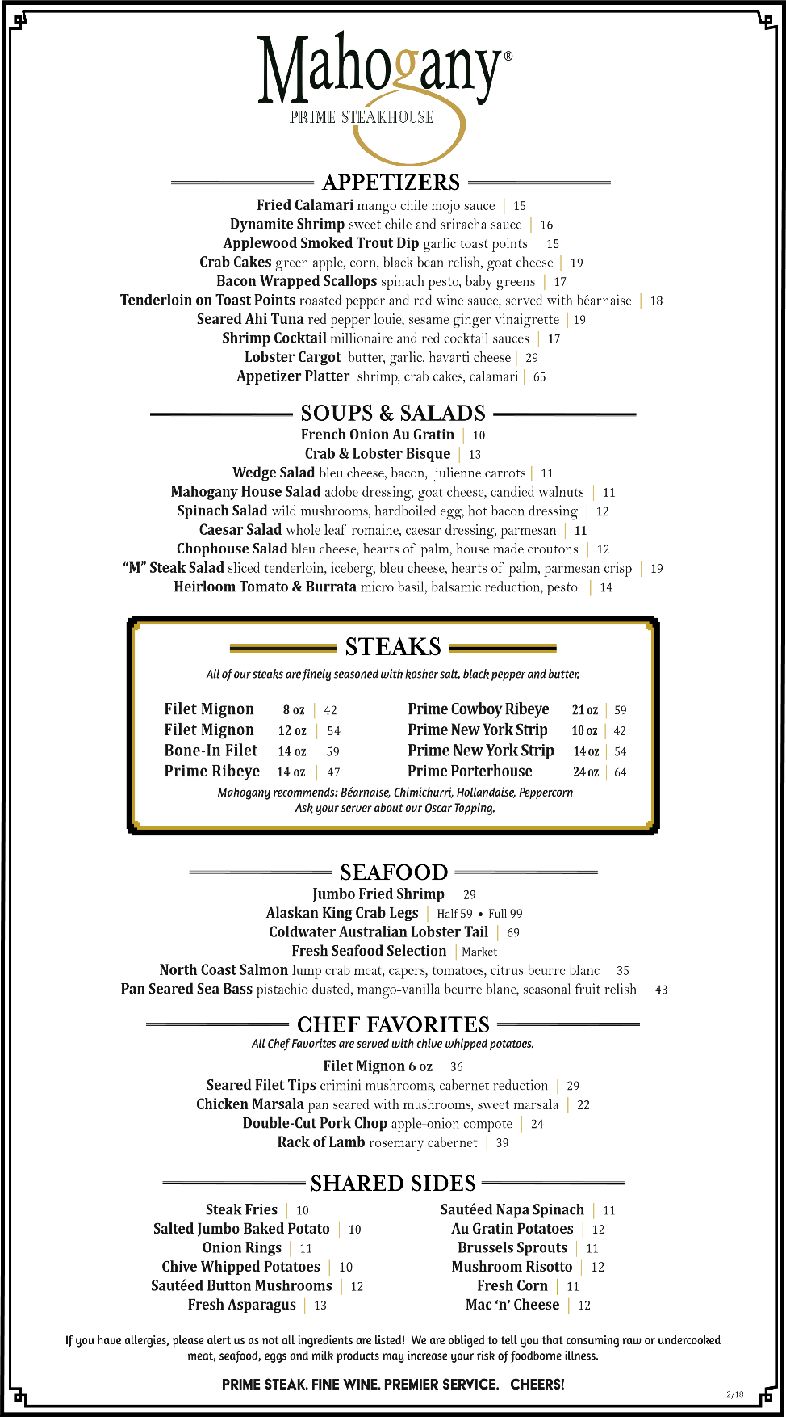

**The Nieport Flight**

Discover the profound difference of young vs. aged ports, and enjoy the wine that evolves with time |38

# fortified & Late

# Harvest wines

***Nieport Tawny*** | 9

***Nieport Ruby*** | 9

***Neiport 10yr*** | 15

***Neiport 20yr*** | 20

***Nivole* Moscato d’Asti *2019*** | 8

**Fonseca Bin 27 Reserve Porto *2019*** | 9

**Rare Wine Co. Charleston Sercial Madeira** | 12

**Trimbach Gewurztraminer Alsace *2012*** | 13

**Chateau Guiraud “Sauternes” *2008*** |14

**Trefethen Late Harvest Riesling *2013*** | 17

**Far Niente *Dolce 2013*** | 30

*Please Ask Your Server about Any Additional Allocated Spirits Not Listed, Drinks, Pairings, or After Dinner Experiences*